Setting up online examinations – support for staff

Support for staff

If you need assistance with building examinations or with examination settings please get in touch with the eLearning team. You can discuss your requirements through live chat or by requesting a one-to-one meeting via Zoom.

Details about how to contact us to arrange support can be found at our website: https://elearning.bmh.manchester.ac.uk/

An easy way to find this address is to look in Blackboard at any of your course units. The Support for Staff menu item points to the eLearning Team website.

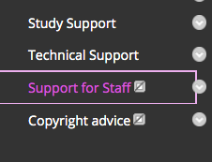
Contacting the eLearning team: Support for Staff

Support for students during the examination

We offer several student support options that can be put in place for the duration of the examination. Details are given in the email templates provided with this document.
Important: you must book student support with the eLearning team in advance of publicising it to students so that we are aware of the need to support the examination.

Template examination information email to send to students

Two Word templates have been provided that contain multiple options you can edit to reflect your examination set-up and local circumstances:
- Template email to students taking Blackboard Tests (MCQs, short answer questions etc)
- Template email to students taking Turnitin-based examinations
You should edit the sections that are highlighted in yellow before sending the email to your students.
The templates can also form the basis of examination instructions within Blackboard.
Setting up an examination area in Blackboard
The eLearning team would suggest that you set up an Examinations area to hold the examination information and the examination paper. We would recommend that information about the examination is made available as early as possible, with the examination itself on timed release.

The Examinations area is usually either a separate left hand menu item, or a folder at the top of the home page.
Here, an ‘Examinations’ link is shown near the top of the left-hand menu:

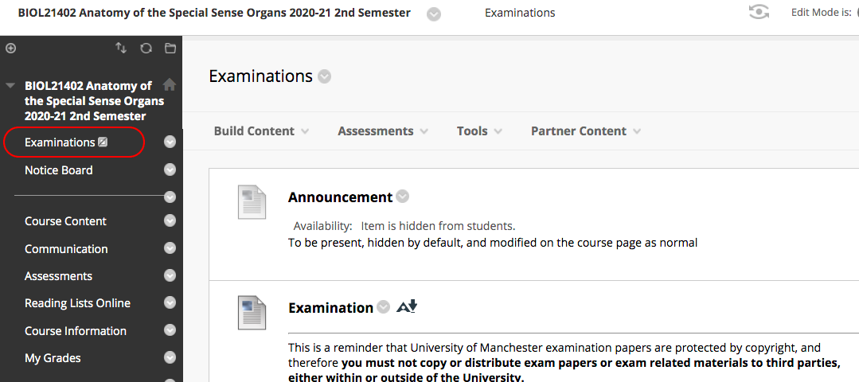
Examinations section in the left-hand menu

Alternatively, you may prefer to place an Examinations folder at the top of the course hom page:
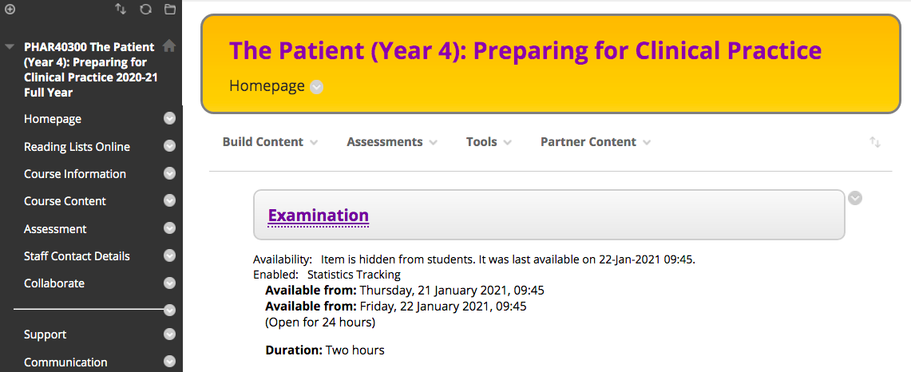
Examinations folder shown near the top of the course home page

The eLearning team can assist with creating examination areas and examinations and can advise on settings. We can also advise on adaptive release, use of groups, application of extra time for DASS supported students, marking, exporting grades, management of grade centre columns, hiding and releasing grades.

Practice submissions

If your students are taking an online examination for the first time or would benefit from a refresher, the eLearning team can make a practice submission area available for Turninin, Blackboard Tests or Blackboard assignments.
Online resources and training on examination-related topics

For your convenience, links to exam-related resources and training have been brought together in this web page on our site.
https://elearning.bmh.manchester.ac.uk/uncategorized/preparing-for-delivery-of-semester-2-assessments-useful-materials/
If you have any other requirements, please get in touch. https://elearning.bmh.manchester.ac.uk/

Survey of examination support requirements

We are reviewing the results of the survey we recently asked assessment leads to complete and will update our training and support resources to bridge any gaps. In the meantime, if you have any needs you feel are not currently being met, or wish to discuss possible solutions with us, please get in touch.
https://elearning.bmh.manchester.ac.uk/

