Classroom guide to teaching with LAMS (i.e. monitor view)

How do I get myself and my students into LAMS?

- You and your students need to go to https://manchester.lamsinternational.com. Some users may find that missing the https:// part of that address means they can’t connect. In these cases, typing the full address will work. Googling for “Manchester LAMS” or similar terms will not find the right environment.
- Usernames are set to student/staff email addresses.
- Passwords will have been created by the student in response to an enrolment email. If students/staff cannot remember their password, they should reset it themselves immediately using the “Forgot your password” link from the LAMS front page. You do not need to ask eLearning to reset passwords on behalf of students or staff members.

How do I open the monitor view to see my students progress and control the lesson flow?

- Once you are logged in, you should
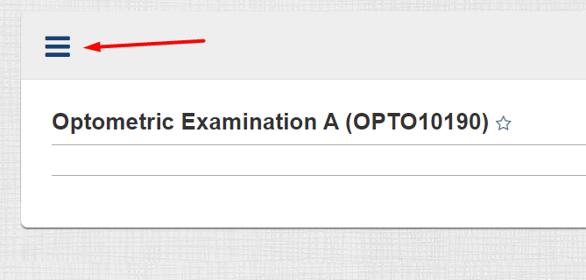
be taken to the course page for your unit (e.g. OPTO30410 - Low Vision (23/24)) If you are not taken directly to your page, clicking the three blue lines in the top left-hand corner will open a course menu page on the left of your screen and, from there, you will be able to select your course unit.

- You then need to click the heart icon to the right of the lesson’s name to open the monitor:
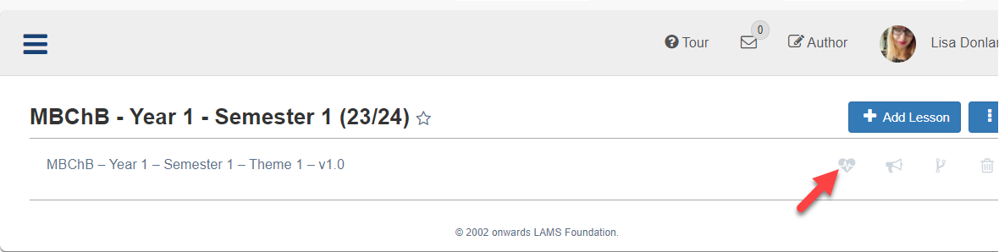
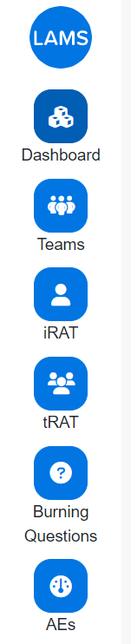
- The monitor view will open on the dashboard page where you can access all the functions you will need via the menu on the left-hand side of the screen and also see the lesson design and the progress of the lesson.

How do I control lesson progress?
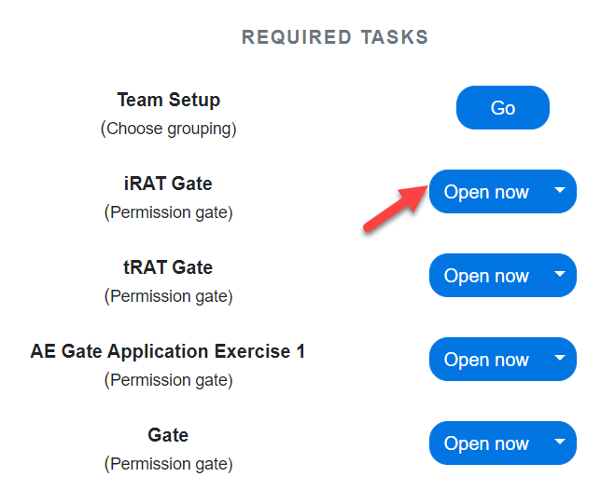
- Progress through a LAMS lesson is controlled through Gates. These appear on the lesson Design view as symbols similar to pedestrian crossing symbols:
 | 
A closed gate | An open gate
Gates may be opened in the Required Tasks section of the LAMS dashboard. In this tab, clicking “Open now” will open the gate for all learners to pass through. IN A MULTI-CLASSROOM SETTING, YOU SHOULD ONLY OPEN GATES IF YOU ARE THE LEAD FACILITATOR FOR THE LESSON.

How do I monitor the iRAT?
To monitor the iRAT stage, select the iRAT tab on the left-hand side of the TBL monitor. This will display a pie chart of how many students have not started, are in progress, or have completed the test. You will also see a table showing the question numbers, the correct answers, and what percentage of students have chosen each answer to a question.
Clicking on the question number will show you the question stem and possible answers.

How do I monitor the tRAT?
To monitor the tRAT stage, select the tRAT tab on the left-hand side of the TBL monitor. This will display a table showing the groups and questions as rows and columns. In each cell, you will see how a group has answered each question. A green icon indicates a correct answer, a red icon an incorrect answer. You can see at a glance which questions have been answered correctly first time, and which have not. The Total and Total % rows and columns relate to correct answers being given first time, not to score.

How do I view Burning Questions?
To see any “burning questions” your learners have asked during the tRAT, open the Burning Questions tab in the left-hand side TBL monitor. This will show you which tRAT questions have burning questions submitted, and whether there are any general burning questions. You can expand each section individually, or use the “Expand all” button to see all questions submitted.

How do I monitor application exercises?
For each application exercise, the AEs tab in the TBL monitor will allow you to see incoming data from students. Each application exercise will have a tab in this section of a monitor, from where you can see incoming answers and, if relevant, start a gallery walk.
You can also track your learners’ progress by double-clicking on the activity in the Design tab of the monitor. This will show you incoming data and allow you to start gallery walks.

Basic troubleshooting
Alternatively, the categories below cover all common errors experienced during class.

A student can’t log in
Check they are trying to access the right LAMS account – it should be manchester.lamsinternational.com, not alternatives like demo.lamsinternational.com or translations.lamsinternational.com.
If a student’s account is locked out, they will have failed to log in on three consecutive attempts. Their account will have been frozen for 2 minutes, which cannot be overridden. They should use the “Forgot your password?” link on the LAMS login screen to reset their password.
You can also access an online Troubleshooting decision-maker covering all log-in queries that are likely to arise during classroom settings here: https://elearning.bmh.manchester.ac.uk/uncategorized/lams-login-issues-troubleshooter/

A student’s account is frozen
Following 3 unsuccessful log in attempts, a LAMS account will be frozen for 2 minutes to prevent brute-force account hacking. If a student has their account frozen, they will need to wait 2 minutes, then try again. If they are not sure of their password, they should reset it as above. The account freeze cannot be overridden.

A student isn’t seeing what they should, or can’t progress in the lesson
The most likely cause of a student being unable to move on is that their LAMS session has timed out. This can happen after ~10 minutes of inactivity, and is most commonly seen during or after the tRAT for people who are not team leaders. In such cases, students should try to:
- Refresh their browser window (ctrl+R on windows, cmd+R on Mac). If this does not work:
- Close the browser window and reopen the lesson. If this does not work:
- Close LAMS and log back in, then reopen the lesson.

LAMS has frozen and I can’t do what I need to
Your session may have timed out if you have been away from your computer for a while. You should try to:
- Refresh their browser window (ctrl+R on windows, cmd+R on Mac). If this does not work:
- Close the browser window and reopen the lesson. If this does not work:
- Close LAMS and log back in, then reopen the lesson.

I can’t see student responses to a RAT or Application Exercise
If you check immediately after making an activity available, you may not find options to see student responses. These only become available once students start to submit work. Wait a short while and you will be able to see incoming data.

